**Dataset:** I have taken a free dataset from Kaggle.com to carry out the visualization on Tableau interface. This dataset contains all the occurrences happened in crossing the border into the US as by the bureau of transportation statistics, govt. of the US. This dataset tells about the incoming counts into the US. This is a vital dataset to predict the average incoming counts into the future seeing the current data trend. This dataset has the data from January 1996 to February 2020 of the total incoming crossing counts into the US.

This dataset has seven columns specifying the port and its unique code, the border, the mode of vehicle used, number of people crossing the border into the US, the data and time of the crossing the state in which they entered. The attributes of seven columns as described above are Port Name – Name of the port, State – state where the port is located, Post Code – it’s the unique code of each port, Border – from which border people are coming to US, Date – the data and time of the crossing the state in which they entered, Measure – the mode of vehicle used, Value – number of people crossing the border into the US.

By using the above dataset, visualizations are done to tell the story which I have chosen for the audience. So, the story I have chosen is, How many people are migrating from each port into all over US by different means of transportation and analysis that number in every year from January 1996 to February 2020.

**Step 1:** Inserting the dataset into the Tableau Interface.

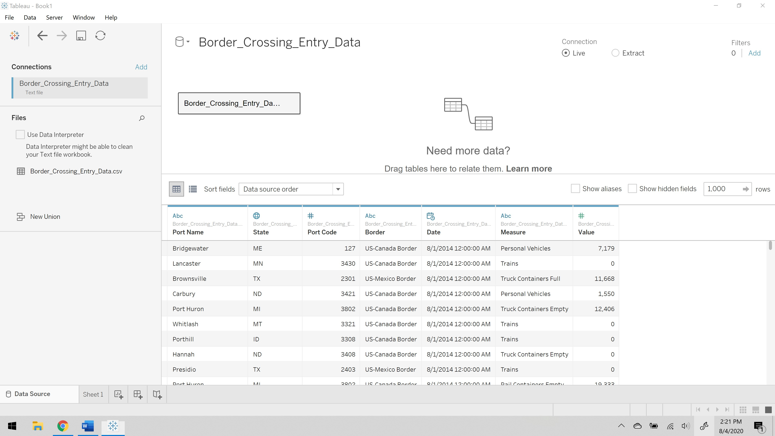

**Step 2:** Creating a new worksheet. Then choosing the attribute which tells the story that need to be conveyed in best possible way.

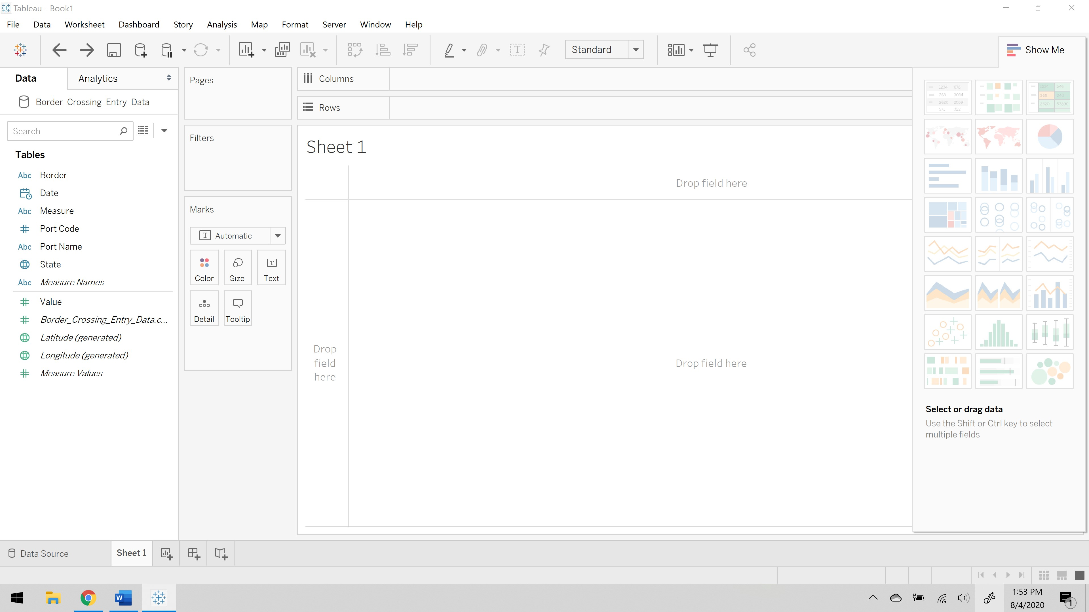

**Step 3:** After dragging data into the sheet, then we need to choose the visual cues that enhances the story in better way.

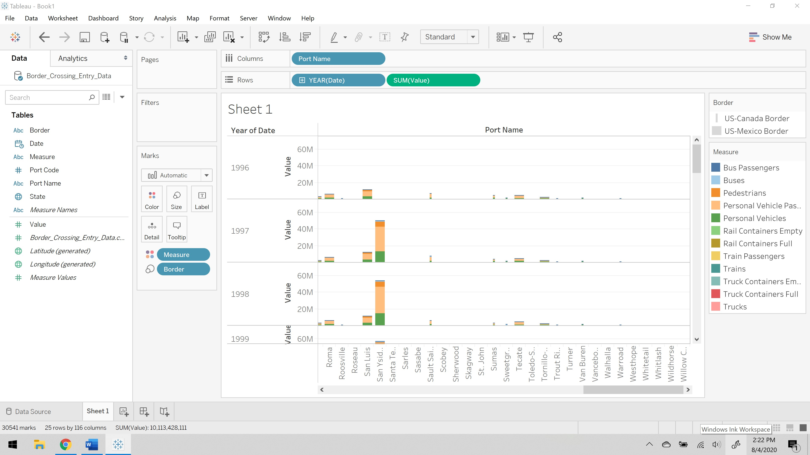

The above visualization explains the number of people that are crossing the border from different ports and through different borders in every year from January 1996 to February 2020 by using different means of transportation. I have taken name of the port that the person is from on the columns, then number of people that are coming into the states of US from records of the govt. of US and the data and time of entering into US is also on to the rows, later the border that the person is getting into US is differentiated with size visual cue and measure which means the mean of transportation into the US are differentiated with the color. This explains the number of people that crossed into US through a border at a date and time by different means of transportation is indicated.

**References:**

[https://www.kaggle.com/divyansh22/us-border-crossing-data/data#](https://www.kaggle.com/divyansh22/us-border-crossing-data/data)